Additional online materials

**eFigure 1**. Directed acyclic graph representing our working causal assumptions.

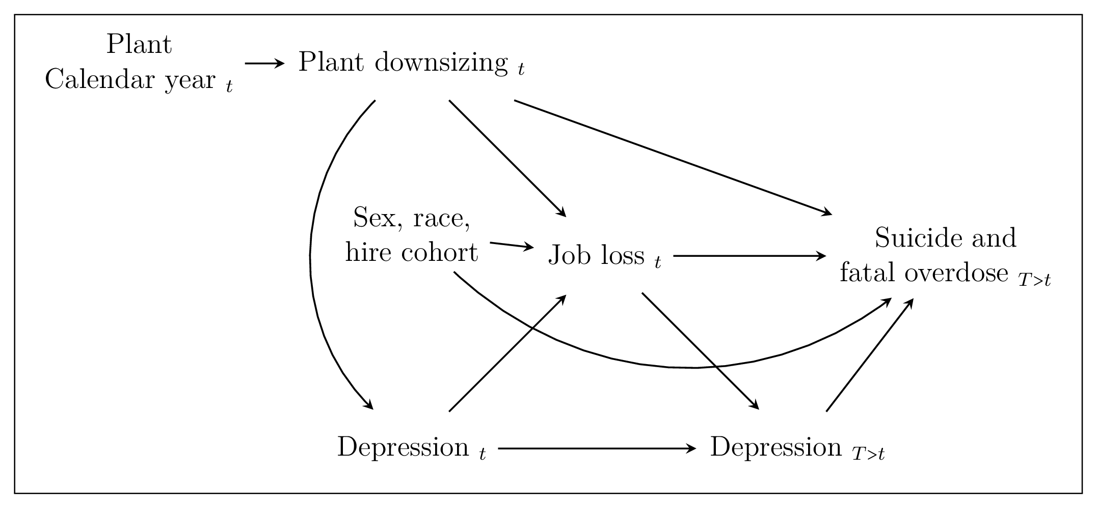

**eFigure 2**. Histograms of age at death among suicide and fatal overdose cases in the **UAW-GM Cohort** restricted to men employed in or after 1970.

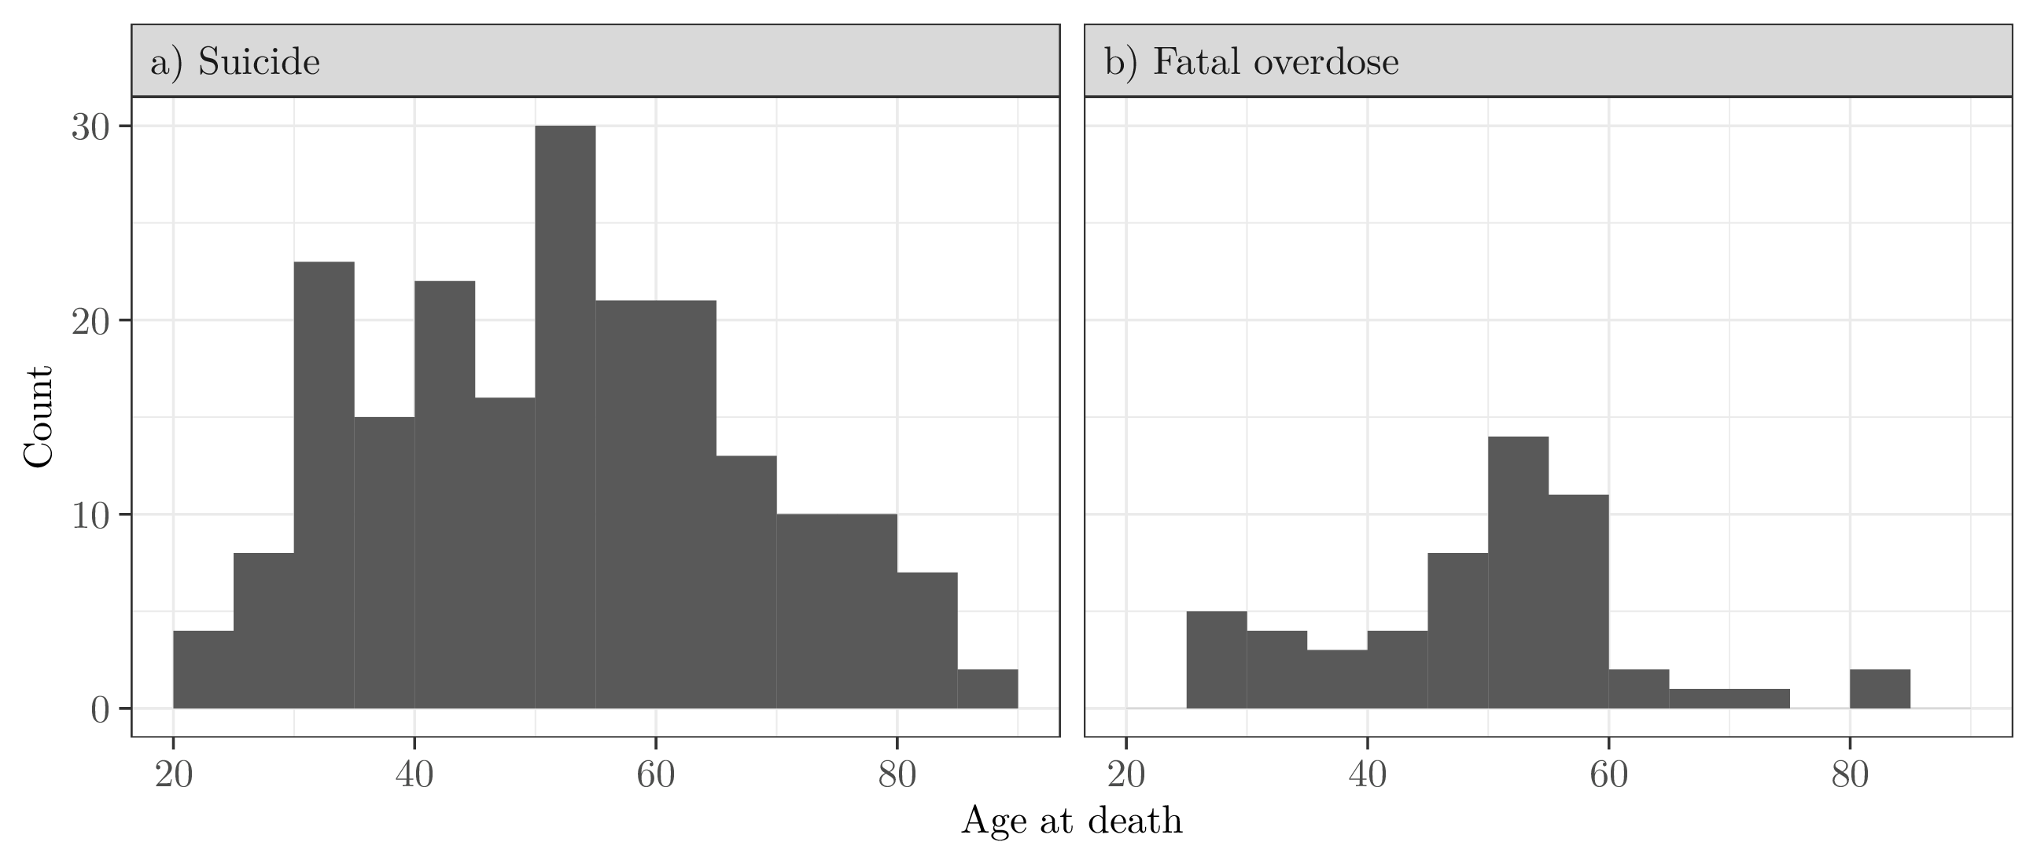



***eFigure 3.*** *Histograms of time between worker exit date and date of suicide in the* ***UAW-GM Cohort*** *restricted to men employed in or after 1970. Bins corresponding to cases that occurred while employed are indicated in purple.*

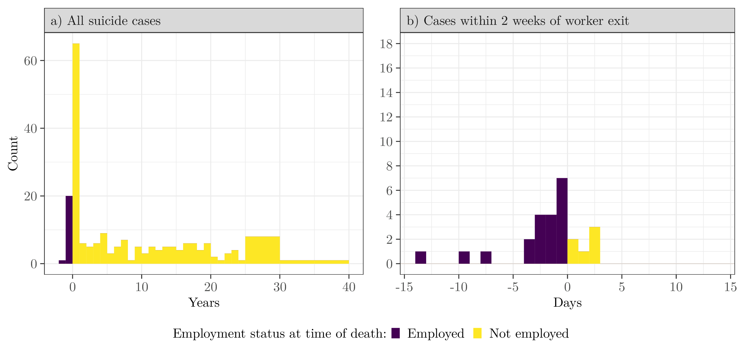

**eTable 1.** Adjusted hazard ratio estimates for **suicide** in the **UAW-GM Cohort** restricted to men employed in or after 1970. Cases that occurred within a week after the recorded worker exit date were assumed to have occurred while still employed.

|  |  |  |  |  |  |  |  |  |  |
| --- | --- | --- | --- | --- | --- | --- | --- | --- | --- |
|  |  |  | Follow-up through 2015 | | |  | 5-year follow-up | | |
| Covariate | Level |  |  | HR | (95% CI) |  |  | HR | (95% CI) |
| Job exit status | At work |  |  |  | – |  |  |  | – |
|  | Not at work |  |  |  |  |  |  |  |  |
| Plant | Plant 1 |  |  |  | – |  |  |  | – |
|  | Plant 2 |  |  |  |  |  |  |  |  |
|  | Plant 3 |  |  |  |  |  |  |  |  |
| Race | White |  |  |  | – |  |  |  | – |
|  | Black |  |  |  |  |  |  |  |  |
| Calendar year of hire | 1938 to 1958 |  |  |  | – |  |  |  | – |
|  | 1959 to 1965 |  |  |  |  |  |  |  |  |
|  | 1966 to 1975 |  |  |  |  |  |  |  |  |
|  | 1976 to 1980 |  |  |  |  |  |  |  |  |
| Calendar year | splined |  |  | – | – |  |  | – | – |
| Estimates were adjusted for plant, race, year of hire, and calendar year. Risk sets were indexed by age. Women were excluded from this analysis.  Cases that occurred within a week after the recorded worker exit date were assumed to have occurred while still employed | | | | | | | | | |



**eTable 2.** Adjusted hazard ratio estimates for **suicide** and the combined outcome of **suicide and fatal overdose** in the **UAW-GM Cohort**, within **five** years of worker exit, restricted to men employed in or after 1970.

|  |  |  |  |  |  |  |  |  |  |
| --- | --- | --- | --- | --- | --- | --- | --- | --- | --- |
|  |  | Suicide | | |  | Suicide & Fatal overdose | | | |
| Age at worker exit |  |  | HR | (95% CI) |  |  | HR | (95% CI) |
| or older |  |  |  | – |  |  |  | – |
| to |  |  |  |  |  |  |  |  |
| to |  |  |  |  |  |  |  |  |
| to |  |  |  |  |  |  |  |  |
| Estimates were adjusted for race, plant, and calendar year of worker exit. Risk sets were indexed by time since worker exit. Women and those with unknown date of worker exit were excluded from this analysis. | | | | | | | | |

**eFigure 4a.** Follow-up diagram for **suicide** cases in the **UAW-GM Cohort** restricted to men employed in or after 1970, ordered by employment worker exit date.

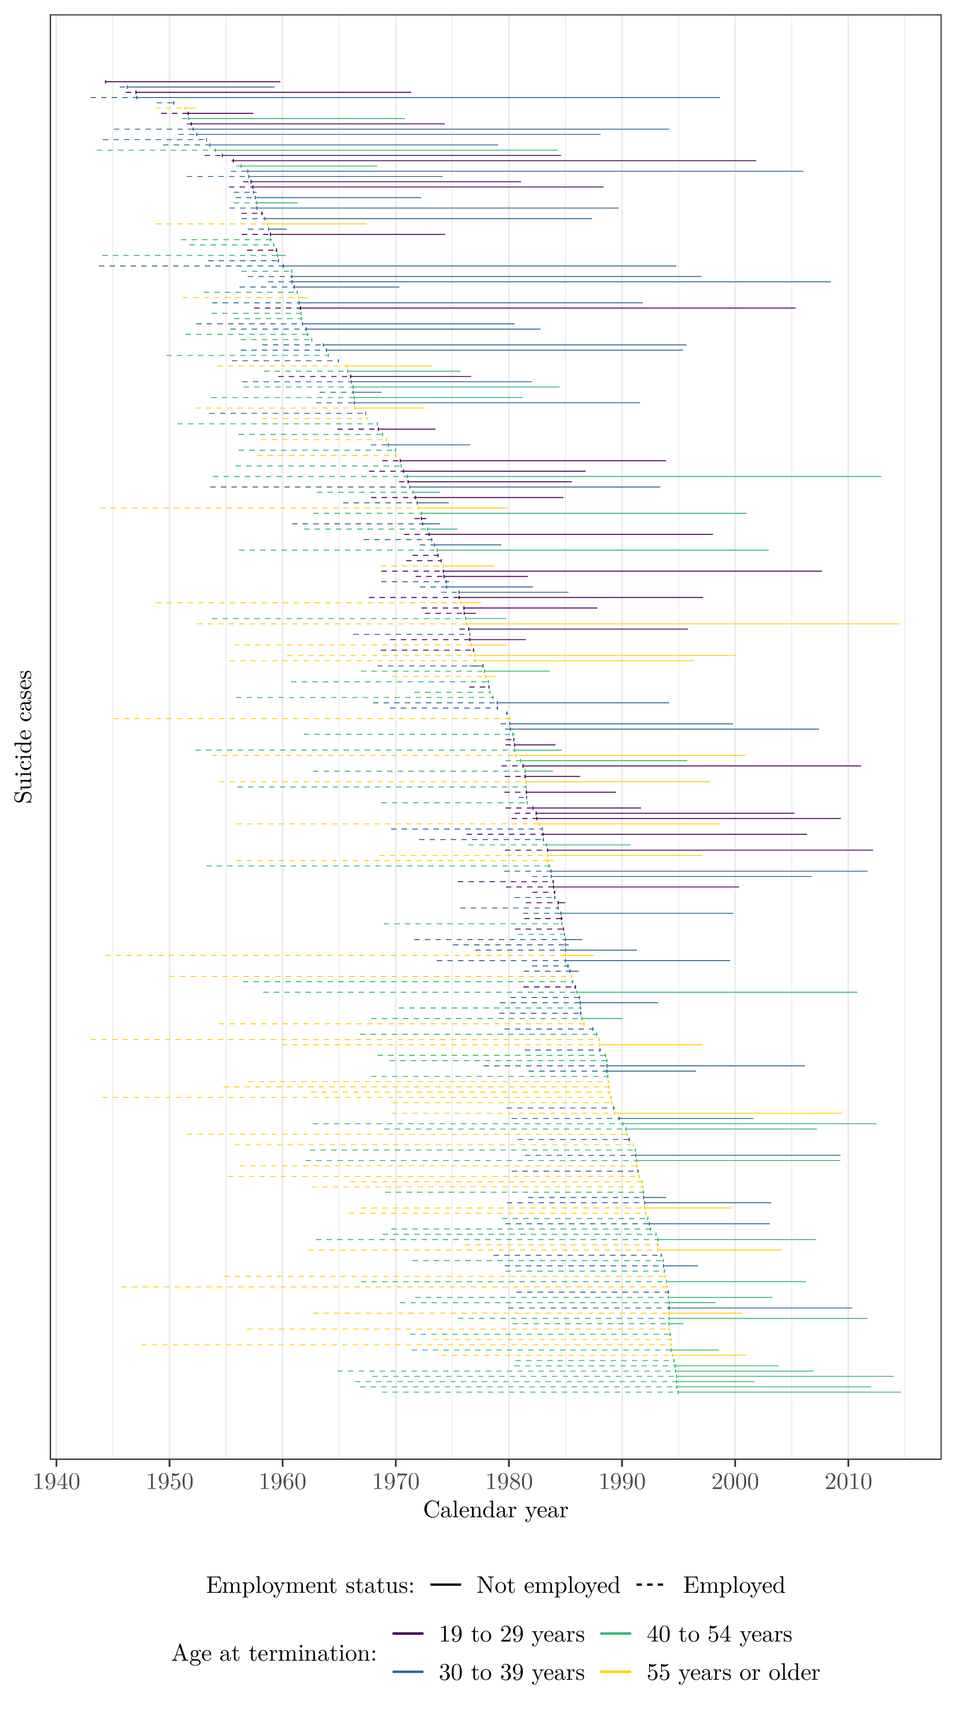

**eFigure 4b.** Follow-up diagram for **fatal overdoes** cases in the **UAW-GM Cohort** restricted to men employed in or after 1970, ordered by employment worker exit date.

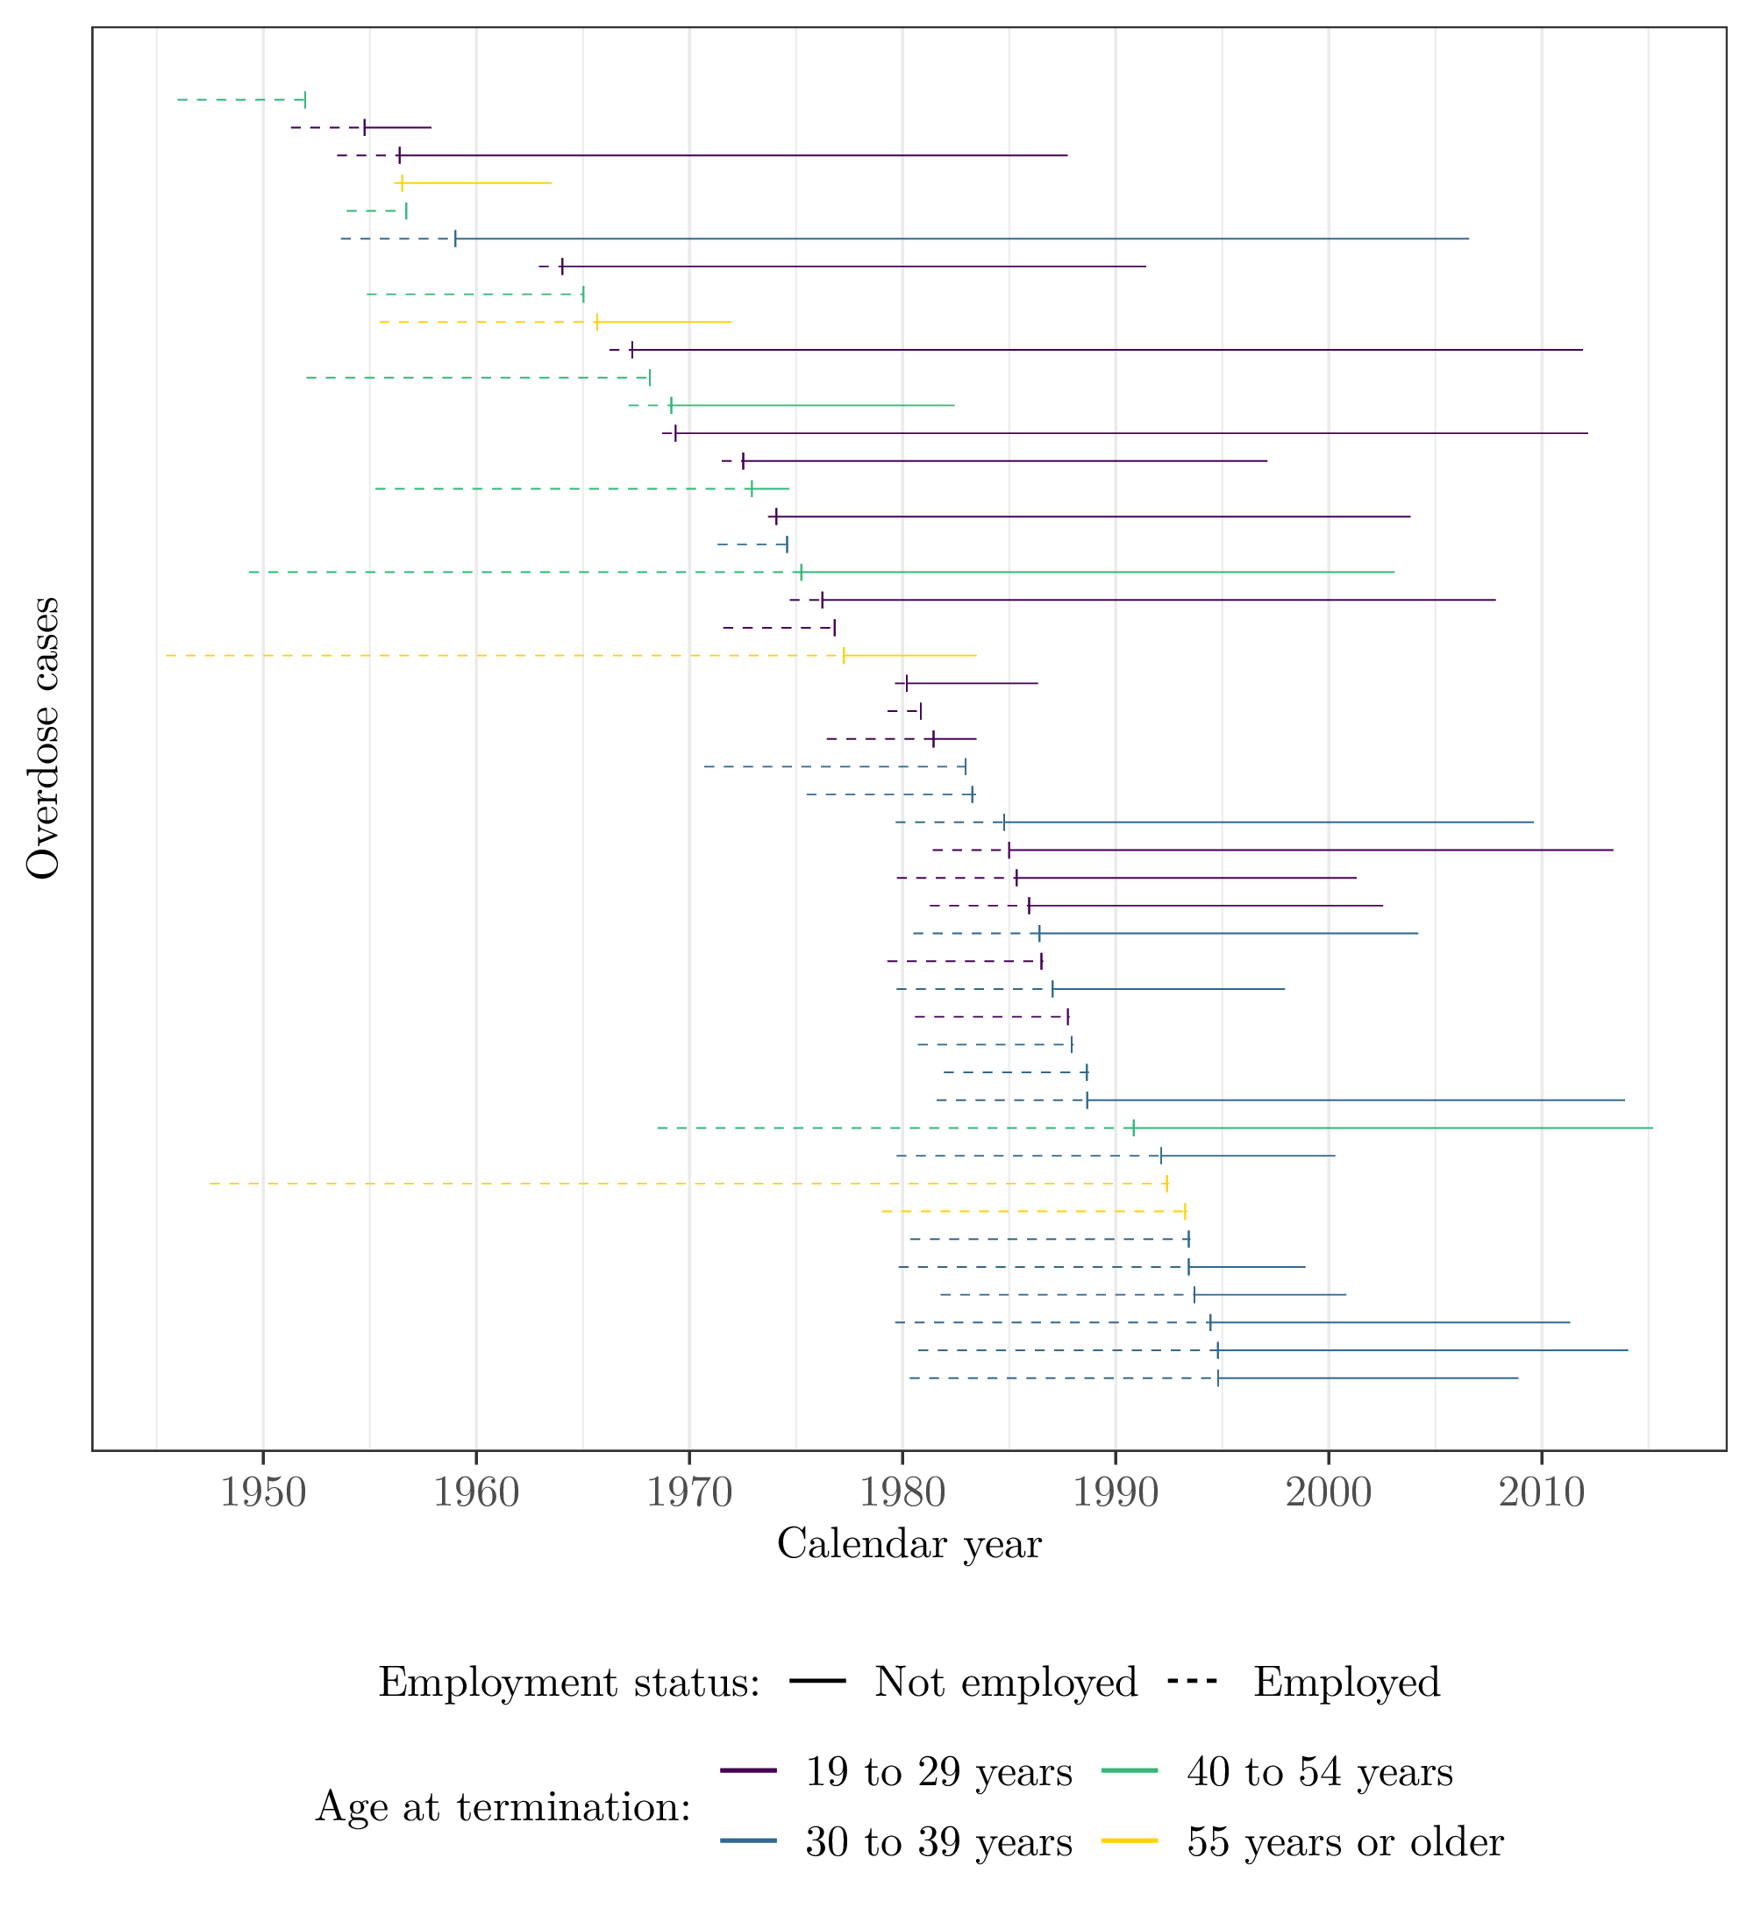

***eFigure 5.*** *Continuous adjusted hazard ratio estimates for* ***suicide*** *and the combined outcome of* ***suicide and fatal overdose*** *in the* ***UAW-GM Cohort*** *restricted to males employed in or after 1970.*

